Early Years (Nur and Rec) Cycle A & B
 |  | Term 1 |  |  | Term 2 |  |  | Term 3
Pathways English |  | Peace at Last |  | Three Little Pigs | Let’s all creek through the  crocodile creek |  | The Pirates are coming | Giganotosaurus | The Sea Saw
A | Cornerstones Driver project |   Me and My Community | 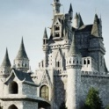Once Upon a Time |  |  Starry Night |  Big Wide World |  | 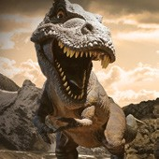  Dangerous Dinosaurs | 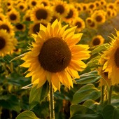  Sunshine and Sunflowers
A | Mini project | Exploring Autumn | Sparkle and Shine |  | Winter Wonderland | Splash! |  | Puddles and Rainbows | Shadows and Reflections
A | Outdoor Provision –  Role Plays | Fire Station (Outdoor)  Home Corner (Indoors) | Builders Yard (Outdoors)  Fairy Tale Castle (Indoors) |  | Dark Cave (Outdoors)  Space Station ? (Indoors) | Car Wash (Outdoors)  Pirate Ship (Indoors) |  | Archaeological Dig (Outdoors)  Cretaceous Camp (Indoors) | Beach Shop (Outdoors)  Seaside (Indoors)
A | Curriculum Enrichment (Trips/Visitors) | PJ Day | New Vic Theatre Trip  Santa Visit to School  Diwali Celebrations |  | Bewilderwood  World Book Day  Chinese New Year | Pirate Wow Day  Eid Fitr? |  | Dinosaur Day | Butterflies Wow/Release Day  (Hatching Caterpillars)
A | Parental Engagement | Tea and Toast  Reception Phonics Phase 2 Meeting  Early Years Open Evening | Christmas Nativity |  | Reception Phonics Phase 3 Meeting | Easter Bonnet Parade and Easter Worship  Mothers Afternoon Tea? (TBC) |  | Daddy’s and Doughnuts Day? (TBC) | New Parents Meeting
A | PSHE (Jigsaw) | Being Me in My World | Celebrating Difference |  | Dreams and Goals | Healthy Me |  | Relationships | Changing Me
A | Music (Charanga) | Me! | My Stories |  | Everyone! | Our World |  | Big Bear Funk | Reflect, Rewind and replay.
A | RE (RE Today) | Why is the word God so important to Christians? | Whys is Christmas special to Christians? (Nativity) |  | Being Special: Where do we belong? | Why is Easter special to Christians? (Easter Garden) |  | Which places are special and why? | Which stories are special and why?
A | PE | Unit 1 Body Management  Unit 1 Dance | Unit 2 Body Management  Unit 1 Gymnastics |  | Unit 1 Manipulation & coordination  Unit 2 Dance | Unit 2 Manipulation & coordination  Unit 2 Gymnastics |  | Unit 1 Cooperate and Solve Problems  Unit 1 Speed and Agility | Unit 2 Cooperate and Solve Problems  Unit 2 Speed and Agility
A | Poetry | Bundle of rhyme |  |  | Into the pond |  |  | Behold
 |  | Term 1 |  |  | Term 2 |  |  | Term 3
Pathways English |  | The Gingerbread Man | I’m going to eat this ant |  | The Naughty Bus | The Journey Home |  | Supertato |  | The Whale who wanted more
B | Cornerstones Driver project | 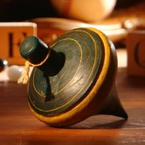 Long Ago | 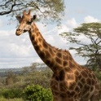 Animal Safari |  | 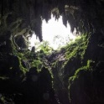 Let’s Explore | 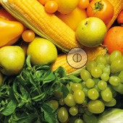  Ready Steady  Grow |  | Marvellous Machines | 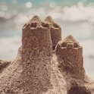 On the Beach
B | Mini project | Stories and Rhymes | Creep, Crawl and Wriggle |  | Build It Up | Signs of Spring |  | Puppets and Pop Ups | Move It Moving On
B | Outdoor Provision –  Role Plays | Cafe (Outdoors)  Bakers kitchen (Indoors) | Safari (Outdoors)  Zoo (Indoors) |  | Bus Station (Outdoors)  Builders Yard (Indoors) | Garden Center (Outdoors)  Farm Shop (Indoors) |  | Police Station/Jail (Outdoors)  Superhero Hideout (Indoors) | Ice Cream Shop (Outdoors)  Under the sea (Indoors)
B | Curriculum Enrichment (Trips/Visitors) | Pumpkin Party | New Vic Theatre Trip  Santa Visit to School  Diwali Celebrations |  | Picnic (on-site)  World Book Day  Chinese New Year | Farm on Wheels/Visit  Eid Fitr? |  | Superhero Wow Day | Blue Planet Aquarium
B | Parental Engagement | Tea and Toast  Reception Phonics Phase 2 Meeting  Early Years Open Evening | Christmas Nativity |  | Reception Phonics Phase 3 Phonics Meeting | Easter Bonnet Parade and Easter Worship  Mothers Afternoon Tea? (TBC) |  | Daddy’s and Doughnuts Day? (TBC) | New Parents Meeting
B | PSHE (Jigsaw) | Being Me in My World | Celebrating Difference |  | Dreams and Goals | Healthy Me |  | Relationships | Changing Me
B | Music (Charanga) | Me! | My Stories |  | Everyone! | Our World |  | Big Bear Funk | Reflect, Rewind and replay.
B | RE (RE Today) | Why is the word God so important to Christians? | Whys is Christmas special to Christians? (Nativity) |  | Being Special: Where do we belong? | Why is Easter special to Christians? (Easter Garden) |  | Which places are special and why? | Which stories are special and why?
B | PE | Unit 1 Body ManagementUnit 1 Dance | Unit 2 Body Management  Unit 1 Gymnastics |  | Unit 1 Manipulation & coordinationUnit 2 Dance | Unit 2 Manipulation & coordination  Unit 2 Gymnastics |  | Unit 1 Cooperate and Solve ProblemsUnit 1 Speed and Agility | Unit 2 Cooperate and Solve Problems  Unit 2 Speed and Agility
B | Poetry | Creepy Crawly Busy bugs |  |  | Farmyard |  |  | Eat your peas Louise

Nursery Maths Curriculum (Master the Curriculum):
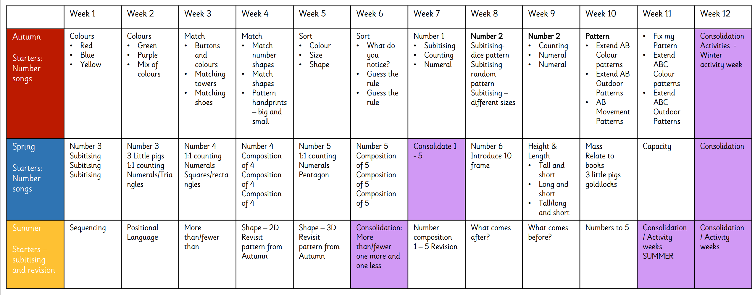

MATHS – EYFS | Term 1 | Term 2 | Term 3
Maths  NUR | Nursery Maths Curriculum – See Above
Maths  Rec | Unit 1 – Numbers to 5  Unit 2 – Comparing groups within 5  Unit 3 – Shape  Unit 4 – Change within 5  Unit 5 – Number bonds within 5  Unit 6 - Space | Unit 7 – Numbers to 10  Unit 8 – Comparing numbers within 10  Unit 9 – Addition to 10  Unit 10 – Measure  Unit 11 – Number bonds to 10  Unit 12 – Subtraction  Unit 13 –Exploring Patterns | Unit 14 – Counting on and counting back  Unit 15 – Numbers to 20  Unit 16 – Numerical patterns  Unit 17 – Shape (composing and decomposing shapes)  Unit 18 – Measure (Volume and capacity)  Unit 19 – Sorting  Unit 20 - Time

Worship Leader Program | Term 1 - Autumn | Term 2 - Spring | Term 3 - Summer
YEAR A | Session 1 | Session 2 | Session 3
YEAR B | Session 4 | Session 5 | Session 6

Oracy Program | Term 1 - Autumn | Term 2 - Spring | Term 3 - Summer
YEAR A | Framework strands (physical, linguistic, cognitive, social and emotional)  Listening skills (listening ladder)  Discussion guidelines | Framework  Protocols for talk  Talk tactics  Types of talk (Exploratory talk) | Types of talk (cumulative and disputational)  Groupings for talk  Framework
YEAR B | Framework strands | Types of talk | Teacher benchmarks 1,2 and 3

