





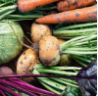

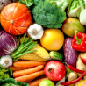
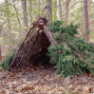
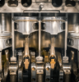
KS3
Taxi!
Key:
Food and Nutrition
Structure
Mechanisms
Greenhouse
Cook well, Eat well
Architecture
Eat the Seasons
Moving Mechanisms
Chop, Slice and Mash
Shade and Shelter
Making it Move
EYFS
KS1
LKS2
UKS2

Year A







Me and My Community
Big Wide World
Once Upon a Time
Starry Night
Dangerous Dinosaurs
Sunshine and Sunflowers



Make Do and Mend
Engineer
EYFS
KS1
LKS2
UKS2
KS3

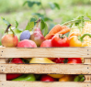
Food for Life




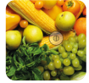

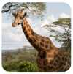
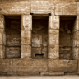
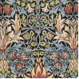
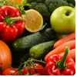



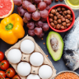
Let’s Explore
Marvellous Machines
Long Ago
Ready Steady Grow
On the Beach
Animal Safari
Year B
Tomb Builders
Functional and
Fancy Fabrics
Fresh Food, Good Food
Beach Hut
Key:
Food and Nutrition
Structure
Mechanisms
Textiles
Push and Pull
Cut, Stitch and Join
Remarkable Recipes

