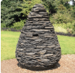
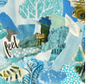

Nature’s Art
Mixed Media
UKS2
KS3
LKS2
KS1
EYFS
Year A
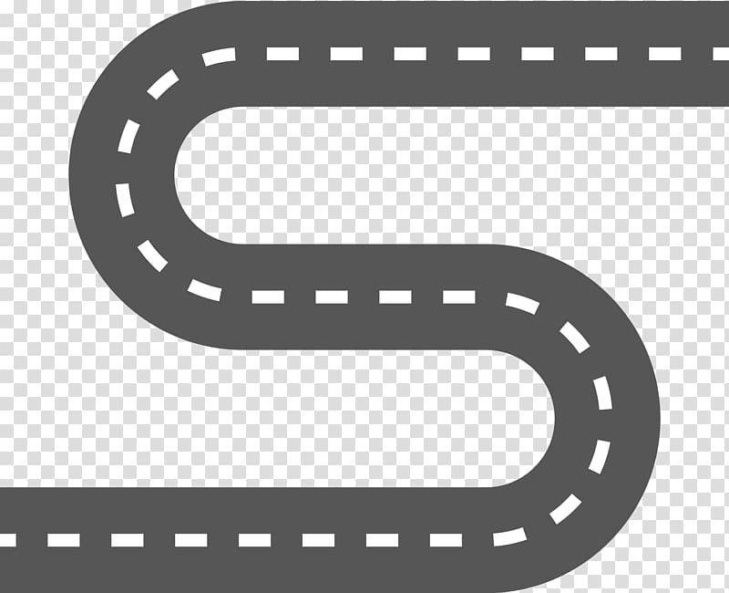
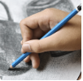
Line, Light and Shadow

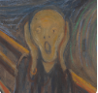
Expression

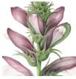
Beautiful Botanicals
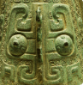
Taotie
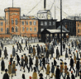
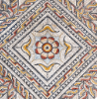
People and Places
Mosaic Masters
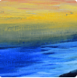
Colour in Landscapes


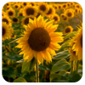
Big Wide World
Sunshine and Sunflowers

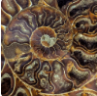
Ammonite
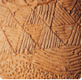
Prehistoric Pots
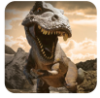
Dangerous Dinosaurs
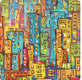
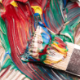
Street View
Mixing Colours



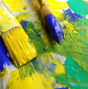
Starry Night
Me and My Community
Key:
Clay
Print
Fabric
Sculpture
Drawing
Paint and Colour
Colour Theory
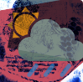
Rain and Sunrays

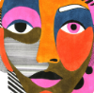
Funny Faces and Fabulous Features

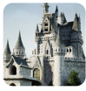
Once Upon a Time

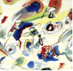
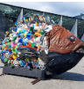
Distortion and Abstraction
Environmental Artists
EYFS
KS1
LKS2
UKS2
KS3
Year B

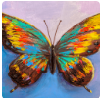
Bees, Beetles and Butterflies
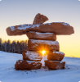
Inuit

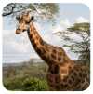
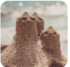
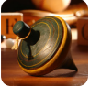

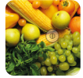
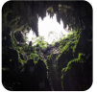
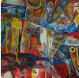
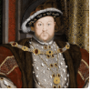
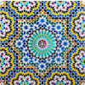
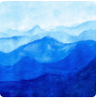
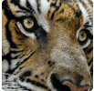
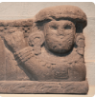
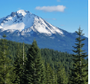
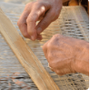
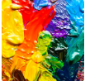
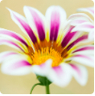
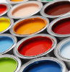
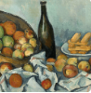
tatues, Statuettes and Figurines
Animal Safari
On the Beach
Long Ago
Marvellous Machines
Ready Steady Grow
Let’s Explore
Trailblazers, Barrier Breakers
Key:
Clay
Print
Fabric
Sculpture
Drawing
Paint and Colour
*Cultured art
Portraits and Poses
Islamic Art
Colour and Style
Animals
Statues, Statuettes and Figurines
Vista
Warp and Weft
Warm and Cool Colours
Flower Head
Exploring Colours
Still Life

