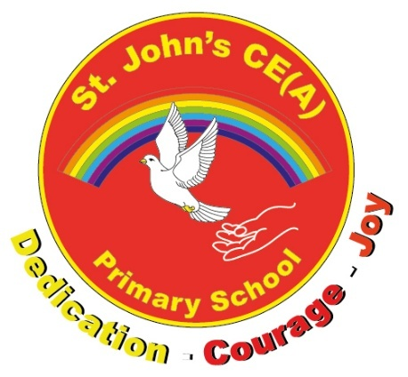
St John’s CE (A) Primary School
Wheatly Avenue
Trent Vale
Stoke-on-Trent
ST4 6SB
Tel: 01782 238889
Headteacher: Mrs S Bowyer

11th March 2026
Dear Parents and Carers,

Ofsted Inspection Report Card – 13th January 2026

As many of you know we received a routine inspection from Ofsted in January and we were one of the first schools in the city to be inspected using the new Ofsted framework. There is now a new report card system to report on the outcomes of this inspection. The link below explains the new report cards and grading system that is now being used:

Understanding Ofsted report cards and grades - GOV.UK

Our full report card can be found either on our website or on the official Ofsted website (when published). A copy has also been attached to this email for you to view. Please take time to read the report card, as there are so many celebrations of our school community - this letter offers just a summary of some of the findings.

The school is delighted to have received 6 out of 7 areas graded at the ‘expected standard’ and all safeguarding requirements have been met. This outcome shows the huge amount of progress that has been made since the last inspection and is testament to the hard work and dedication of the entire school community.

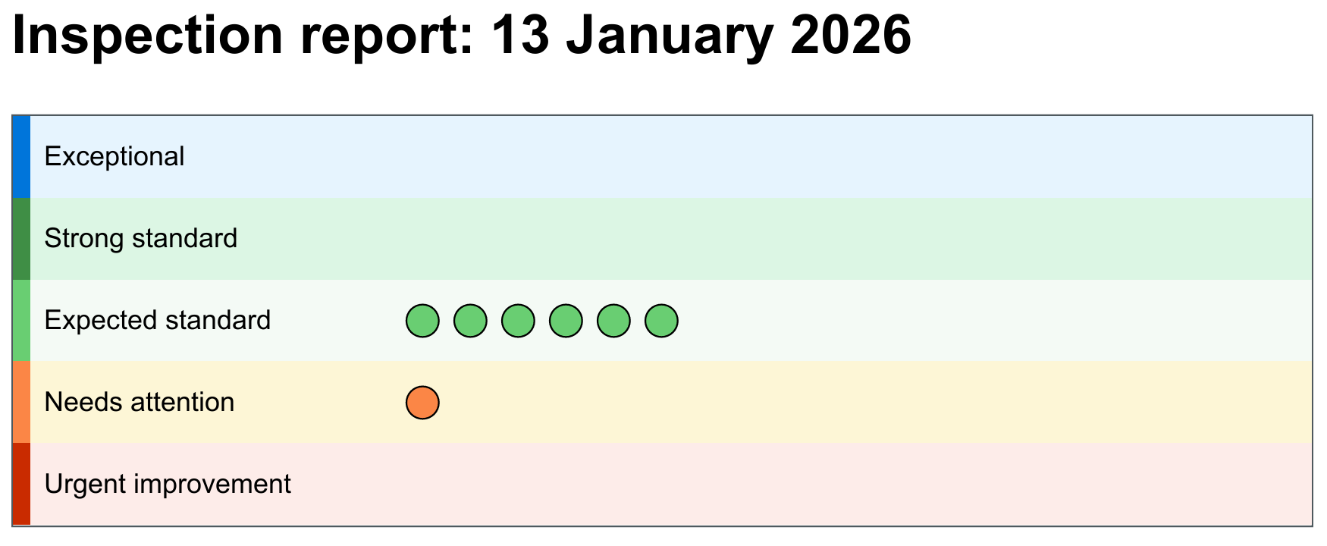
What our grades mean:


The ‘expected standard’ is just that – it means the school or other provider is doing everything that it should be doing, so you’ll see the green colour coding on the report card. It’s a high standard, to make sure your children are receiving everything they need and deserve.
Taken from - Understanding Ofsted report cards and grades - GOV.UK

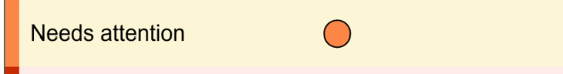
‘Needs attention’ is an indication that there is work to be done to reach the ‘expected standard’. It’s not a ‘fail’.
Taken from - Understanding Ofsted report cards and grades - GOV.UK

The vision for St. John’s is that all will flourish and to ensure the whole child is developed. We believe our school is a haven for all children. It is wonderful to have the inspectors recognise this:

Leaders at St John’s Primary aspire for pupils to ‘Live life to its fullest’.

There is a particularly harmonious atmosphere across the school.

We have got to continue with a celebration of our children in this report. They demonstrate the wider values they need for life now and in the future, including the high aspirations that our children have for their long-term goals:

They say that one of the best things about their school is that ‘everyone is kind’.

Pupils learn to respect themselves and others. They confidently talk about making decisions based on their morals. For example, they explain that ‘two wrongs do not make a right'.

Pupils think about the knowledge and skills they need to pursue their ambitions.

Our staff team have worked incredibly hard working on the previous Ofsted targets and meeting the demands of the changing Ofsted framework. Along with you and our children, our staff team are always focused to ensure our school is welcoming:

Warm, positive relationships help staff get to know pupils quickly,…

The new Ofsted focuses heavily on leadership, including school governors. The relentless work leaders are undertaking is making a difference:

Leaders have an effective understanding of the context of their school. They use this knowledge to identify suitable areas for improvement.
Governors are well informed and carry out their roles diligently. They know that the school has improved significantly in some areas since the previous inspection. Governors effectively support leaders to continue improvement.

Leaders at St John’s Primary aspire for pupils to ‘Live life to its fullest’. They set high expectations for pupils’ learning, behaviour and personal development.

Of course, our parents and carers are a key part of our school, helping to support your children and create the positive culture that we want for our community. We appreciate the partnership that we have with you and were delighted to receive so many positive comments via the ParentView questionnaire that was sent out by inspectors:

'Staff know their pupils well and create a very nurturing environment. They also do their best to get to know and support families.’

Parents are very supportive of the school. They appreciate the progress made by leaders across all aspects of the school’s work, particularly in recent years.

Next steps

Ofsted graded 1 area as ‘Needs Attention’, meaning some further work needs to be done in this area. Whilst the area of achievement covers many aspects, the area for development in our case is the outcomes in writing. Inspectors acknowledged the progress made in the areas of reading and maths.

The key areas for improvement identified in the Ofsted report are accurately reflected in the school’s School improvement Plan and School Evaluation Form which demonstrates that school leaders know the school well. As Ofsted validated our School Improvement targets, our School Improvement Plan actions will still continue as they are, with opportunities to review and refine as the year progresses. The next steps for the school are outlined below:

Target 1: Leaders should ensure that the teaching of important knowledge and skills in writing enables pupils who have gaps in their writing knowledge to improve the quality of their writing.

This target will be a next step to secure the expected standard in the ‘achievement’ area of the report.

Inspectors recognised the important work undertaken in Early Years to give pupils strong foundations for future learning:

Leaders ensure that children have a successful start to their learning in the early years. Children feel safe and settle successfully into an environment which is engaging and stimulating. Leaders give careful thought to how the curriculum supports children’s’ progress through the early years.

Our curriculum and teaching is graded to be at the expected standard, and inspectors acknowledged the steps that have already been taken to improve pupil achievement across the school:

They have strengthened the English and mathematics curriculum so pupils build knowledge securely over time.

They are effectively addressing issues with regard to pupils' achievement in reading and mathematics. They have ensured that weaknesses with writing are being addressed. This is having an impact, particularly where pupils have experienced the new writing programme in full.

Outcomes in writing remain stubbornly low. Leaders have addressed this with the implementation of a structured writing programme. Pupils who have experienced this curriculum in full are achieving well in writing.

There is further work to undertake in order to improve our children’s writing. The Department for Education acknowledge in the new writing framework (2025) that ‘Learning to write is one of the hardest challenges pupils face at school’. As some children join or leave our school at different points, they sometimes will have larger gaps and have not experienced the full curriculum at St. John’s. Writing is built on strong foundations and the development of oracy skills, which is why we have invested a great deal of time and effort into these areas, which inspectors valued.

Target 2: Leaders should continue to strengthen support for teachers to ensure that adaptations for pupils with special educational needs and/or disabilities are consistently matched to their needs, so that pupils learn well across all subjects.

Inclusion was graded to be at the expected standard and this target will be a next step to secure the strong standard.

Leaders identify pupils’ needs swiftly. Leaders closely track the progress of pupils with special educational needs and/or disabilities (SEND). This helps staff understand pupils’ needs as soon as possible. Leaders maintain high expectations and match support carefully to each pupil.

Leaders set targets for pupils with SEND that are specific, measurable and achievable. They review these regularly and adjust learning activities if necessary. Staff receive training in this approach and typically meet pupils’ needs well. They use this advice and guidance to best support pupils.

Within our Early years

Staff and child interactions are positive. Staff support children well, particularly children with special educational needs and/or disabilities. This leads to children securing knowledge typically well.

To continue to secure the stronger standard, we are working through our School Improvement Plan to ensure that we continue to develop our skills in these areas. This will include making adaptions for our pupils with more complex needs.

Target 3: Leaders should further ensure that subject leaders support staff to deliver the curriculum effectively so that all pupils achieve well in every subject.

Leadership was graded at the expected standard, and this target will be a next step to secure the strong standard.

Leaders work hard to ensure that pupils achieve well.

This work is showing positive results, although some pupils have gaps in important knowledge about writing.

Leaders ensure that staff receive an effective and research-led professional learning programme which enables staff to fulfil their respective roles well.

Leaders have empowered subject leaders to have oversight of and to further develop their curriculum areas.

Staff are very positive about the support they receive from leaders. One comment from staff stated, ‘Leaders have established a positive culture where staff feel supported and motivated.’ This is typical of the views of many staff.

To continue to secure the stronger standard, we are working through our School Improvement Plan where leaders will continue to identify school context and ensure our leaders skills are matched to support all of our children. We will be refining our evidence led leadership programme, which Ofsted praised in their report.

Inspectors highlighted numerous areas that are well on the way to achieving the strong standard and we will continue to develop these. For example, inspectors praised how well our pupils behave, their attitudes towards learning and the personal development work that we undertake.

To conclude, again we will return to our children. We truly believe our children at St. John’s make our world a better place to be and this was summarised in a comment by one pupil to the inspectors:

‘It doesn’t matter who is in it, everyone is family.’

We look forward to the next stage of our journey with you all. As always, if you have any questions or comments, please do come and speak to us.

Yours sincerely

SM Bowyer L Jones

Mrs SM Bowyer Mrs L Jones
Headteacher Chair of Governors

