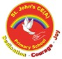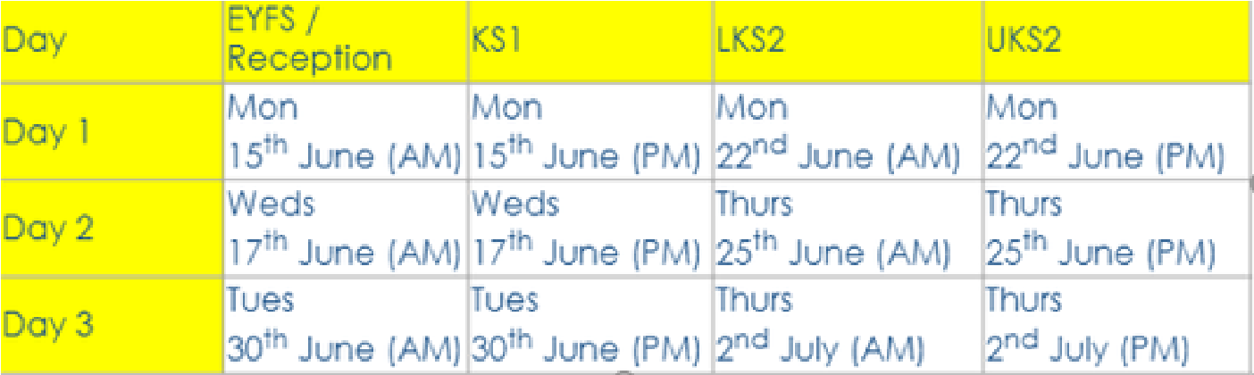
‘I have come in order that you might have life – Life in all its fullness.’ John 10:10
Sports Day (day 2 & 3 are reserve days)
y
Dates for
our Diar
y

pril
A
Week commencing 27
April & 4
May
All Years 3,4 &5 to complete Level
&2 Bike Right Training
1

th
th
Ma
y
Monday 4
May - Bank Holiday school closed
th
Monday 11
- Thursday 15
Year 6 SATs

th
th
)

s
Issue 25:Friday 24th April 2026
Dear parents and carers,
An action packed start to the term, thank you for the great routines
of getting to school on time, school uniform and also undertaking
that homework...well done!
An impressive visit by year 5 & 6 to the Catalyst Science Discovery
Centre. It certainly turned out to be more than just looking at
bridges! Miss Miszkiel explained how expertly each group worked
together using team building and problem solving skills. Many skills
they will use in their future careers. They were all very
professional...excellent job year 5 & 6!
A big thank you to all who helped with our Roots week... We are still
talking about this. Our parent visitors were so valuable to the
experience. Cayson's oatcake picture was very well thoughtout using
the heritage of Stoke!

The sunshine is here so enjoy the weekend ahead.
Mrs Bowyer

Headteacher


Year 1
- Jonah and the Whale -

29
/06/
26

Year 3-4
- Pentecost -

18
/05/
26

Parent/Carers you are very welcome to
come and watch your child in their class
worship. All worships start at 9am.

Class Worshi
ps
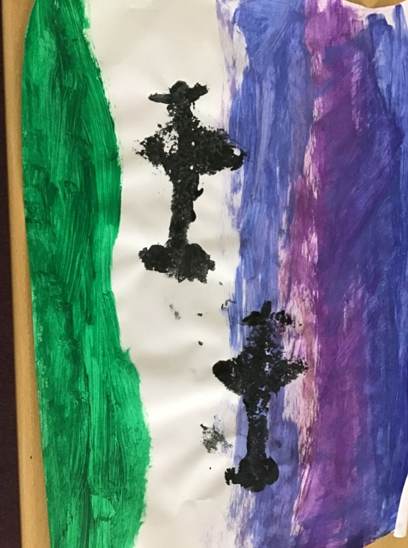
Work from Year 5
In Art, the children have used oatcakes to create stencil pictures.
Sticking to the theme of Roots week, Cayson decided to cut his
oatcake into the shape of the British WWII fighter plane - The Spitfire,
which was designed by Reginald Mitchell. Many of the class opted to
make bottle kilns for their prints, however Cayson mixed his ideas
with his own personal interest and opted to create a picture of two
Spitfires patrolling the skies.
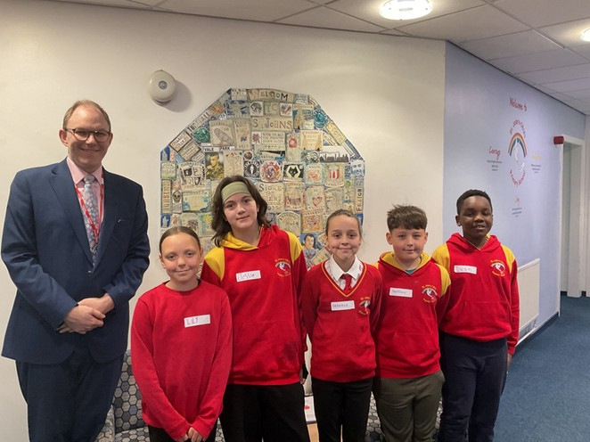

Visit from Gareth Snell MP
Last Friday, 17
April, we were visited in school by
our local Member of Parliament, Gareth Snell.
th
He spent some time meeting our school council, who
asked him questions about life as an MP and also
about what he is doing in parliament to help local
children living in Stoke.
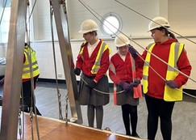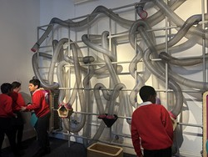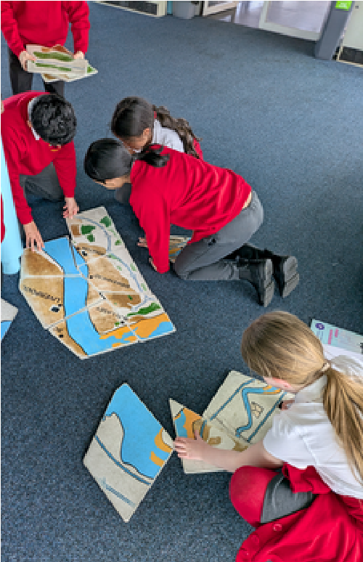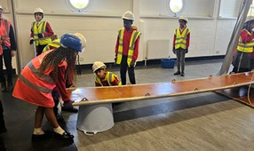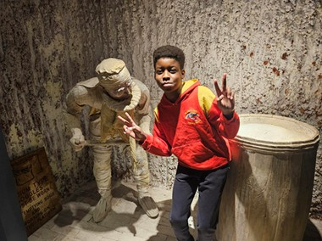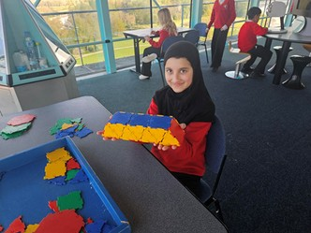
UKS2 had a fantastic time visiting the Catalyst Science Discovery Centre in Liverpool. The
highlight of the trip was the workshop, where pupils designed and built their own bridges before
testing them, allowing them to explore civil engineering in a fun and practical way. The visit also
gave them insight into the birth of industry, alongside a wide range of hands-on and interactive
exhibits that brought science and technology to life. They also spent time in the observatory,
where they took part in activities while enjoying views of the three bridges surrounding the
museum: the Silver Jubilee Bridge, the Mersey Gateway Bridge, and the Runcorn Railway Bridge.
UKS2 Visit

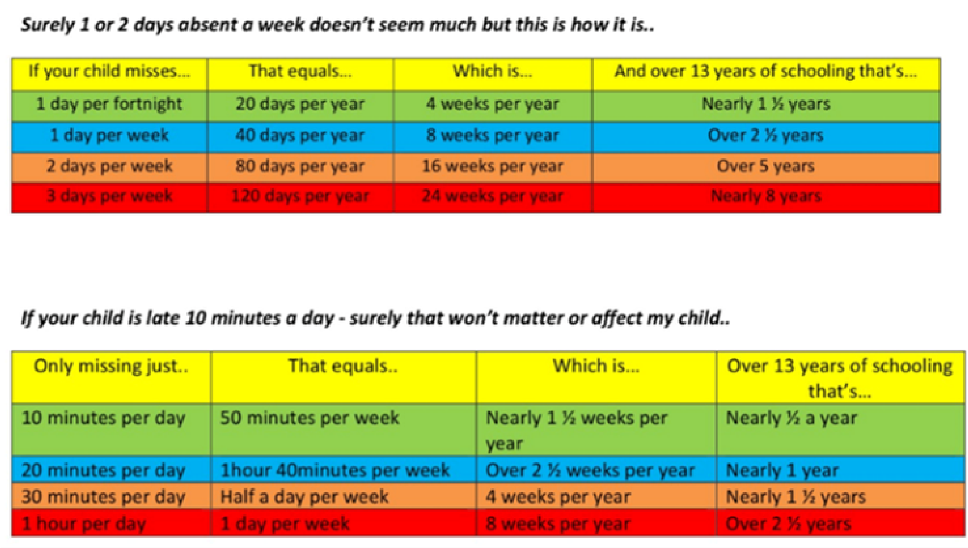


The cree
pin
g
effect of school absence
Many parent/carers do not realise how, over missing 1-2
days through the year (or arriving a few minutes late each
day) accumulates and the impact it has on their child’s
learning, progress, achievement and success over time.
Reminder - school opens at
8.30
am and finishes at
3.10
pm

📣

Spaces Available in Time4Wraparound a
t
St. John's CE(A) Primary Schoo
l
!
Did you know we offer Time4Wraparound, an after-schoo
l
activity programme run by Time4Sport, giving children th
e
chance to try a range of fun, multi-sport activities whil
e
developing skills, staying active and enjoying time with friends
?
⚽
,
Activities can include sports such as football, dodgeball
e
athletics, handball and mor
🏃
Helps children learn new skills and build confidenc
e
🌟
Supports children to achieve the recommended 60 minute
s
of daily physical activity
!
📩
Spaces are still available! To book or find out more, clic
k
here
:
https://enrolmy.com/time-4-sport-uk-ltd/book-now/64
-
Summer-Term-Wraparound-Childcare---St-Johns-CEA-Primary
-
Schoo
l





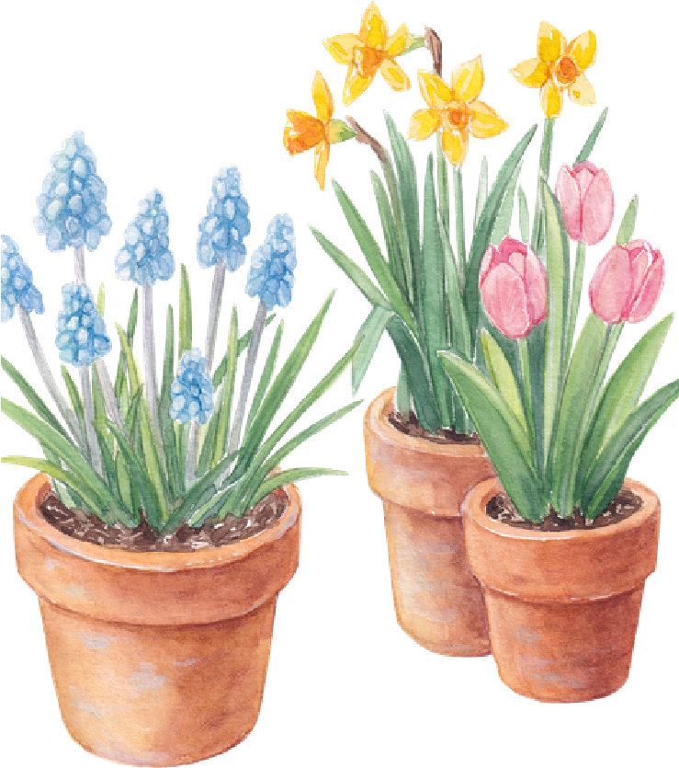
Pra
y
er
Pra
y
er
Dear God,
Thank You for the gift of spring,
for new life, fresh beginnings, and
growing things.
As the flowers bloom and the days
grow brighter,
help us grow in kindness, patience,
and understanding. Amen

